1. 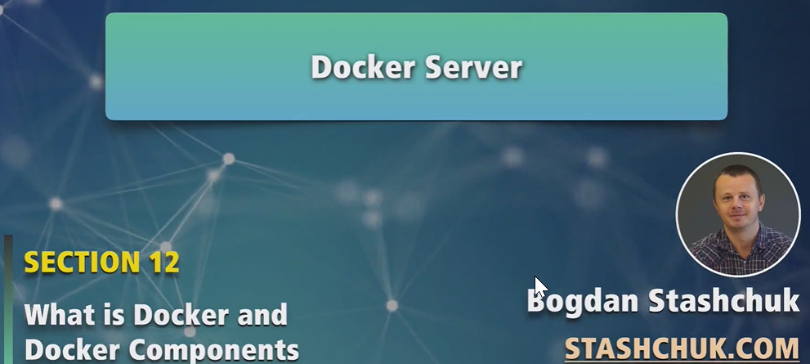
2. In the last lecture, we studied what is Docker client. Actually it is a separate executable file from Docker server located on your computer with which you can connect with Docker daemon (which is part of Docker Server) and send your commands to Docker daemon.   
   **For examples**: The commands to run image and list of running images.
3. Docker Server is a set of different processes and Docker daemon is one of them.
4. 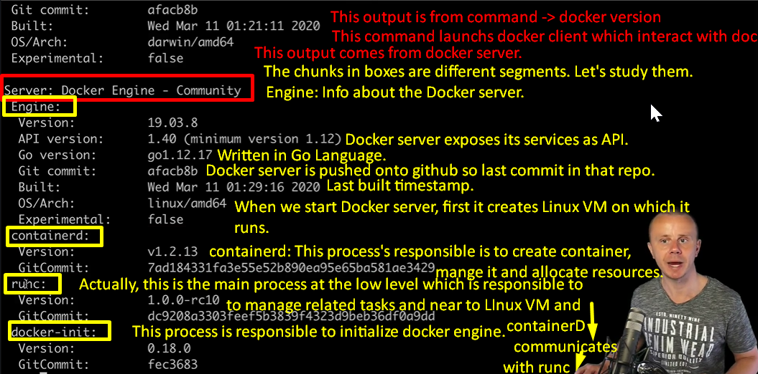  
   **NOTE**: The command Docker version was run on MAC OS still we see OS/Arch : Linux/amd64.   
   The reason is that we have installed Docker Desktop on Mac OS which will first creates and runs Linux VM and then launches Docker Server on that VM.  
   Next will see Docker Server on Ubutnu.
5. Process containerD communicates with the process runc and runc communicates with Linux VM created by Docker server.
6. Runc is responsible for
   1. Creating containers
   2. Allocating resources to containers via Linux VM.
   3. Managing all other processes.

